ADC2 Demo – Power Meter

# Overview

This demonstration uses the ADC in software-triggered one-shot scan conversion of multiple channels (ANI0-ANI3) to create a power meter. Power for two loads is calculated based on voltage drop across the load and the voltage drop across a series resistor.

In this case the loads are a yellow LED and a red LED. The current sense resistors are 15 ohms, leading to a current measurement resolution of 3.3V/(1024*15) = 0.215 mA. Note that the 22 and 150 ohm resistors are for current-limiting to protect the LEDs.

# Connections

|  |  |  |  |
| --- | --- | --- | --- |
| **Description** | **MCU Pin** | **Signal Name** | **Direction** |
| Load 1 Voltage | 56 | AN0 | Input |
| Load 1 Current Sense Resistor | 55 | AN1 | Input |
| Load 2 Voltage | 54 | AN2 | Input |
| Load 2 Current Sense Resistor | 53 | AN3 | Input |
| 3.3 V Power | 15 or 16 | 3V3 | Common |
| Ground | 13 or 14 | GND | Common |

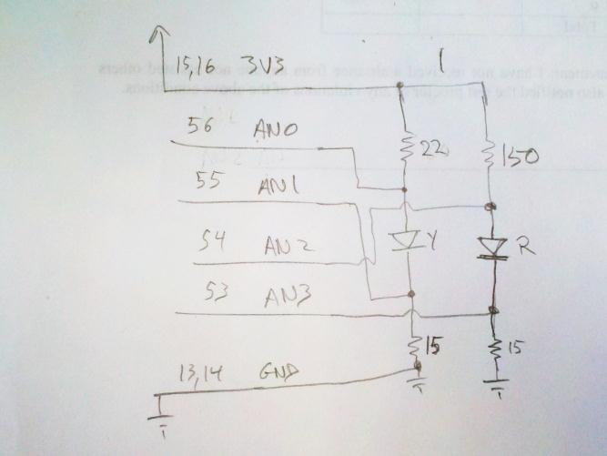

Figure . Schematic of power meter circuit.

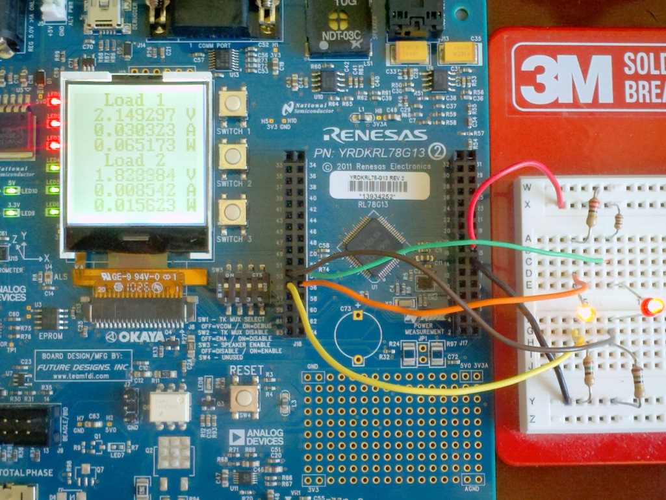

Figure . Power meter circuit implemented on a solderless breadboard.

# Comments and Suggestions

* Try measuring the voltage with a multimeter and evaluate the accuracy of the ADC and software. Don’t forget that the current-sensing resistors induce a voltage drop which is subtracted out in the power calculations.
* The maximum safe input voltage is 3.3 V (the analog supply voltage for the MCU). If you need to measure a higher voltage, use a resistive voltage divider to lower it below 3.3 V and adjust the code accordingly.
* Evaluate the power used by different colors of LEDs. Blue and white LEDs will likely need more than 3.3 V to turn on, so you might want to drive them from 5V and divide down the voltages supplied to AN0 and AN2 using a 2:1 resistive divider.